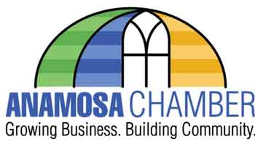
4 Person 9 Hole Best Shot Golf Tournament
September 23rd, 2022 10am Tee Time at Wapsipinicon Country Club
Check in and cart pick up 9:00-9:45
$160 per team

TEAM NAME: _________________________________________________________________
CONTACT PHONE#: ____________________________________________________________
# OF CARTS @ $30 EACH: _______________________________________________________
MULLIGANS 2/$5 MAX OF 8/$20 PER TEAM: ________________________________________
TOTAL DUE: ____________________________PAID: _________________________________
Mail registration form to Anamosa Chamber 213 E Main St Anamosa, IA 52205
Registration and cart fee must be paid by September 16th, 2022 to reserve team and ensure cart availability. Carts are not guaranteed for late registrants. Limited to first 18 teams.
Questions? Email director@anamosachamber.org or call 319-462-4879

*Cart fee is set by the cart rental company. Anamosa Chamber does not retain any cart fee funds.

